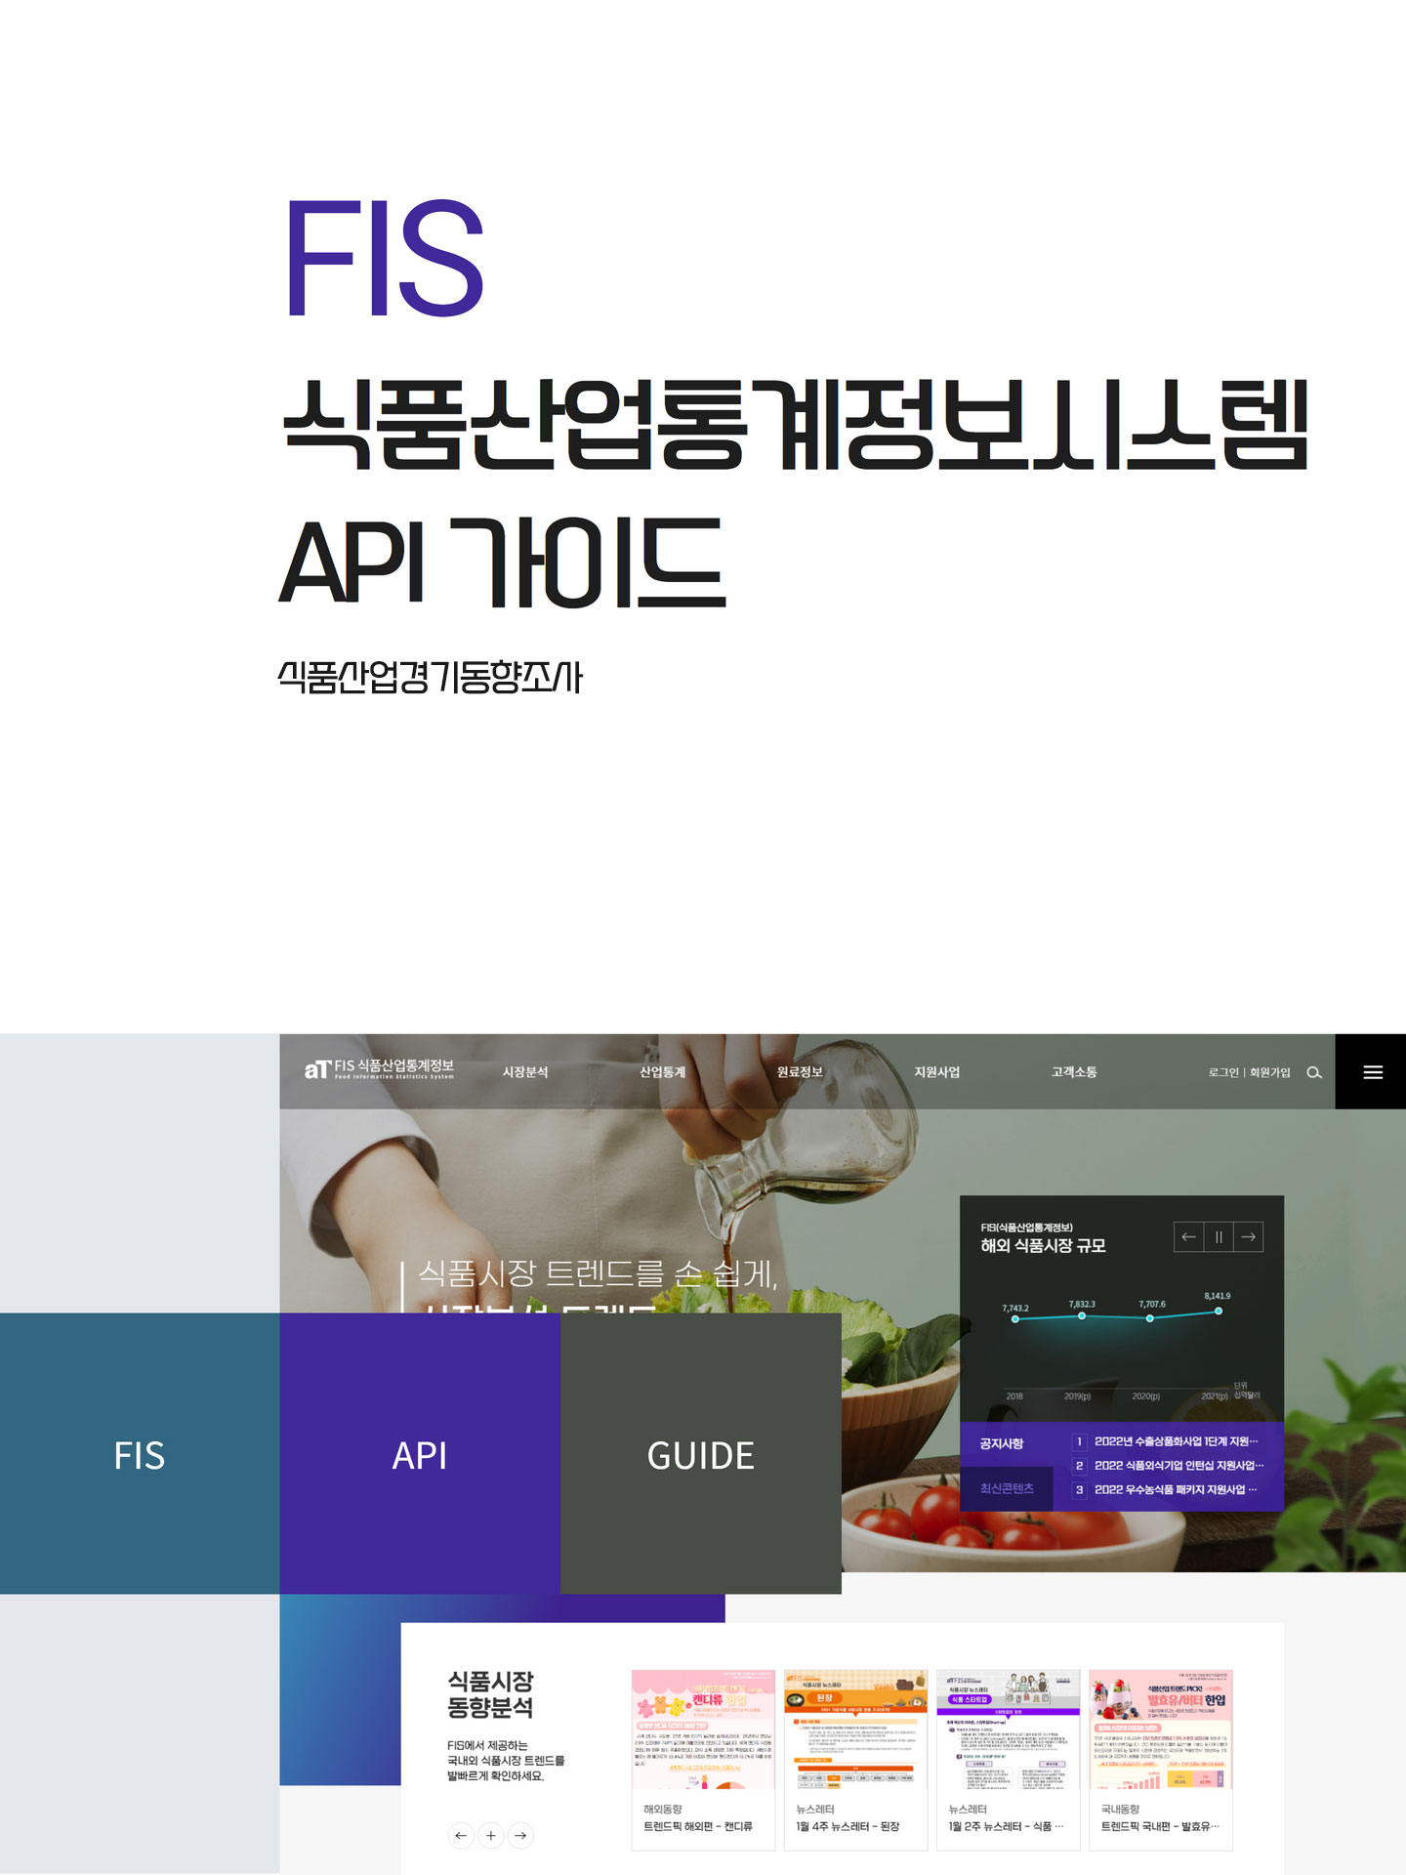

1. **요청URL**

<https://www.atfis.or.kr/home/api/prospect/basic.do>

|  |  |  |  |
| --- | --- | --- | --- |
| 요청변수 | 값 | 설명 | 필수여부 |
| apiKey | string | 인증키 | Y |
| startYear | string | 시작연도(YYYY) | Y |
| endYear | string | 종료연도(YYYY) | Y |
| prspectSe | string | 분류코드 | Y |

1. **샘플URL**

<https://www.atfis.or.kr/home/api/prospect/basic.do?apiKey=z9JeRfaB44up466XHs+5pTcV31n58LqRkSHZ8H66xbw=&beginYear=2022&endYear=2022&prspectSe=current>

1. **샘플JASON**

[{"prspectIndstryId":201,"prspectSe":"current","prspectYear":"2022","prspectQu":"q1","prspectIndstryNm":"곡물 가공품, 전분 및 전분제품 제조업","prspectIndstryIdex":70.9,"prspectPrdctnIdex":98.9,"prspectSelngIdex":93.3,"prspectDmstcIdex":93.4,"prspectXportIdex":94.2,"prspectEmplymIdex":99.7,"prspectRwmatrIdex":159.7}]

1. **분류코드**

|  |  |
| --- | --- |
| **코드** | **코드명** |
| **current** | 현황 |
| **prospect** | 전망 |